**Name:**

**Functions Unit Review**

**Section 1 🡪**

Complete the input-output tables for the following functions.

|  |  |
| --- | --- |
| $$x$$ | $$y$$ |
| 1 |  |
| 2 |  |
| 3 |  |
| 5 |  |
| 10 |  |

**1. $y=f\left(x\right)=3x+2$**  **2. $y=f\left(x\right)=20-3x$**

|  |  |
| --- | --- |
| $$x$$ | $$y$$ |
| 1 |  |
| 2 |  |
| 3 |  |
| 5 |  |
| 10 |  |

**3. $y=f\left(x\right)=-x$**  **4. $y=f\left(x\right)=\left|x\right|+3$**

|  |  |
| --- | --- |
| $$x$$ | $$y$$ |
| 1 |  |
| 2 |  |
| 0 |  |
|  |  |
|  |  |

|  |  |
| --- | --- |
|  |  |
| 1 |  |
| 5 |  |
| 0 |  |
| $-1$ |  |
| $$-5$$ |  |

**State whether or not these tables represent a function and why.**

**5. 6.**

**7. 8.**

**Write the following equations as functions.**

**9. $y+4x=16$ 10. $y-7x=10$ 11. $-15x+y=4$**

$y=$ $y=$ $y=$

**12. $3x+y=17$ 13. $2y+6x=40$ 14. $-6x+3y=18$**

$y=$ $y=$ $y=$

**Are these graphs functions or not?**

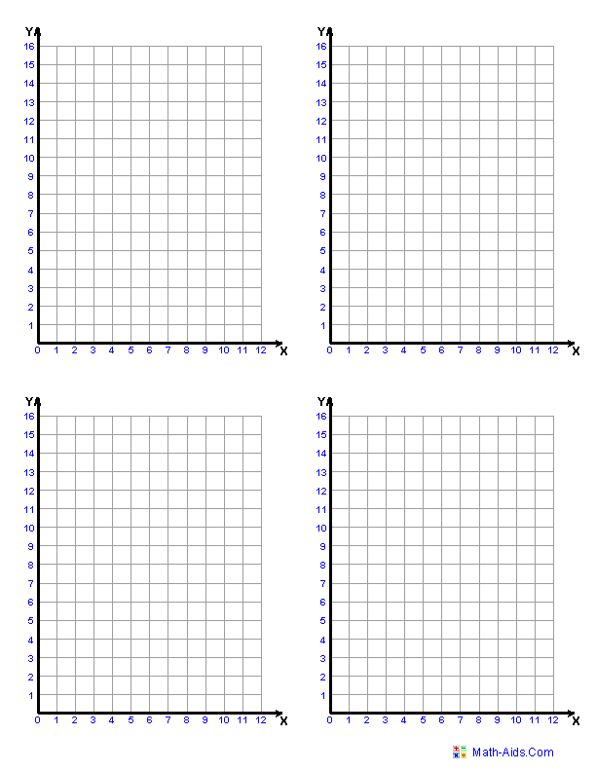**15. 16.**

**17. 18.**